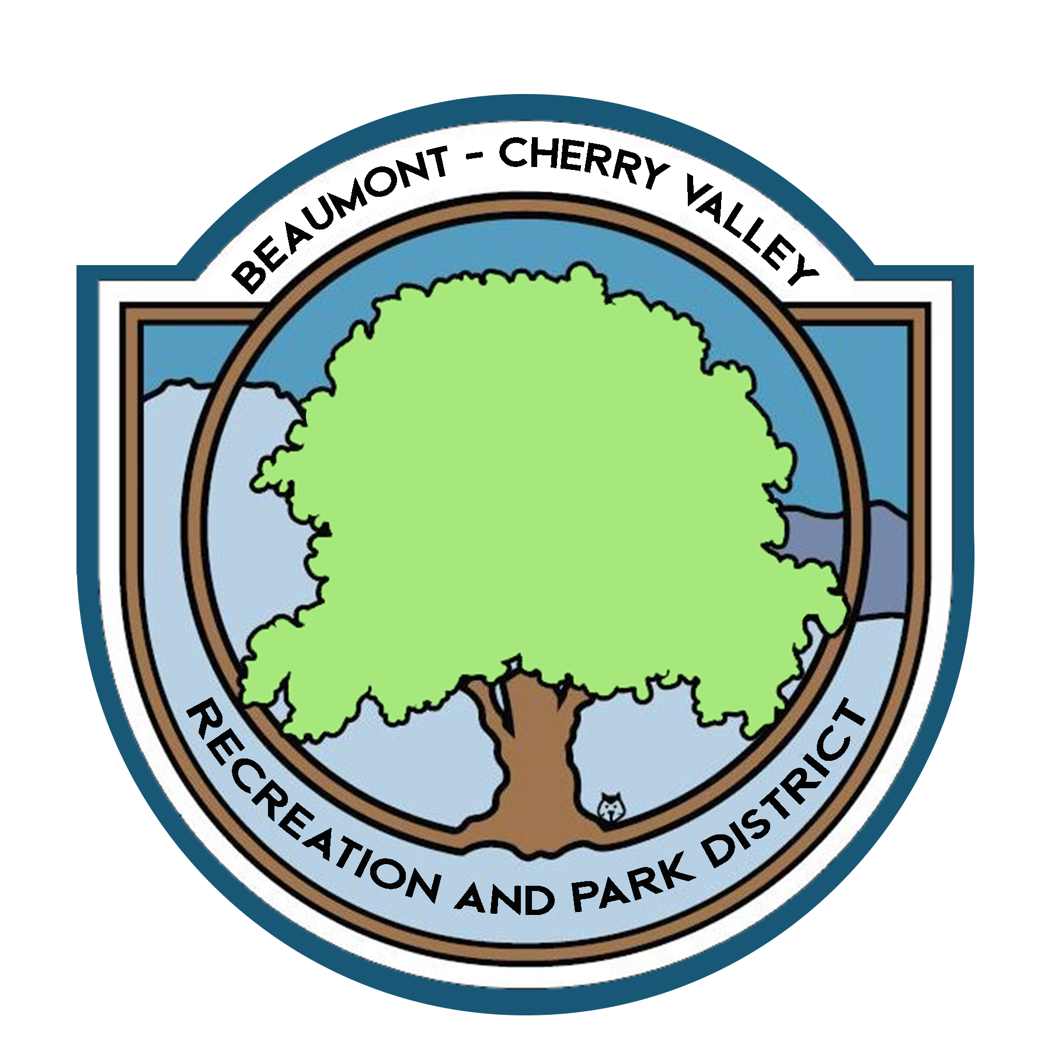

BEAUMONT CHERRY VALLEY RECREATION & PARK DISTRICT
FINANCE COMMITTEE MEETING
Thursday, August 5th, 2021
390 W. Oak Valley Parkway Beaumont, CA 92223

MINUTES
www.bcvparks.com

REGULAR SESSION: Regular Session to Begin at 5:09pm

Roll Call:
Vice Chair/Secretary Diercks __X___ Treasurer Flores__X___ General Manager Burk _A_ Financial Services Technician/Office Manager Law __X___

Adjustments to Agenda: None

- PUBLIC COMMENT: None

- CONSENT CALENDAR:
- 2.1 Minutes of Thursday, July 8th, 2021. Motion was made to approve minutes by Chris Diercks 2nd by John Flores

- ACTION ITEMS
- 3.1 Financial Report July 2021 Motion was made to approve the finance package as submitted by Chris Diercks 2nd by John Flores.
Passed unopposed

- 3.2 Check Warrants July 2021 Motion was made to approve the check warrants by Chris Diercks 2nd by John Flores.
Passed unopposed

- 3.3 Riverside County Fund Request of $300,000.00 (Bills & Payroll) Motion was made to approve the request of $300,000.00 from the Riverside County Fund by Chris Diercks 2nd by John Flores.
Passed unopposed

- ADJORNMENT:
The meeting was adjourned by Chris Diercks at 5:33pm

