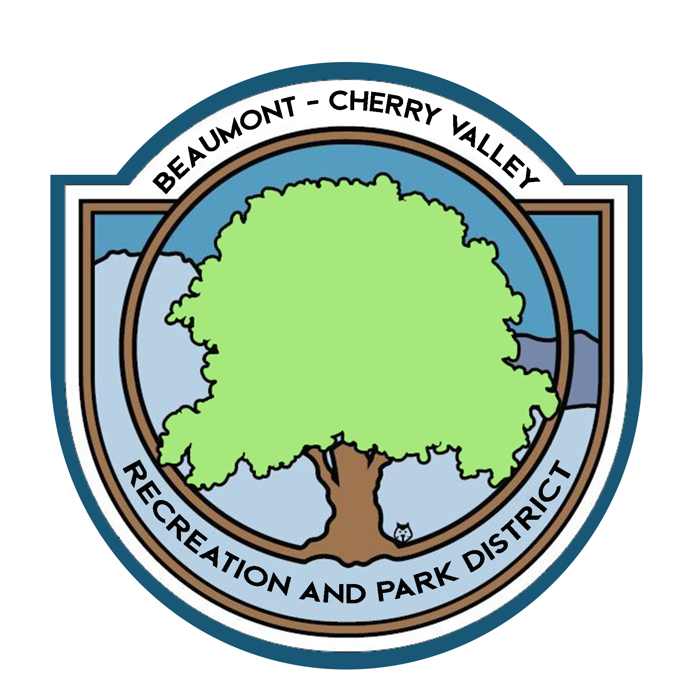

BEAUMONT CHERRY VALLEY RECREATION & PARK DISTRICT
FINANCE COMMITTEE MEETING
Thursday, January 6th, 2022
390 W. Oak Valley Parkway Beaumont, CA 92223

MINUTES
www.bcvparks.com

REGULAR SESSION: Regular Session to Begin at 4:27pm

Roll Call:
Vice Chair/Secretary Diercks __Call___ Treasurer Flores__X___ General Manager Burk _Call_ Financial Services Technician/Office Manager Law __X___

Adjustments to Agenda: None

- PUBLIC COMMENT: None
- CONSENT CALENDAR:
- 2.1 Minutes of Monday, December 6th, 2021. Motion was made to approve minutes by Chris Diercks 2nd by John Flores.

- ACTION ITEMS
- 3.1 Financial Report December 2021 Motion was made to approve the finance package as submitted by Chris Diercks 2nd by John Flores.
Passed unopposed

- 3.2 Check Warrants December 2021 Motion was made to approve the check warrants by Chris Diercks 2nd by John Flores.
Passed unopposed

- 3.3 Riverside County Fund Request of $200,000.00 (Bills & Payroll) Motion was made to approve to raise the request of $250,000.00 from the Riverside County Fund by Chris Diercks 2nd by John Flores.
Passed unopposed

- 3.4 FY 21/22 Mid-Year Budget. Motion was made to approve the FY 21/22 Mid-Year Budget by Chris Diercks 2nd by John Flores.

- ADJORNMENT:
The meeting was adjourned by Nancy Law at 4:46pm

