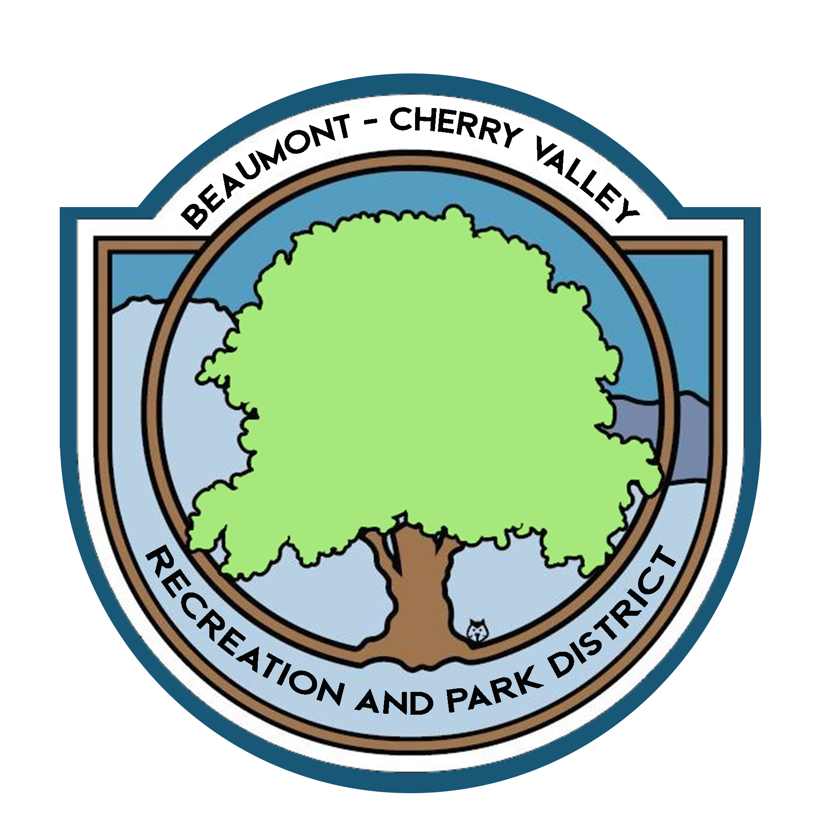

BEAUMONT CHERRY VALLEY RECREATION & PARK DISTRICT
FINANCE COMMITTEE MEETING
Monday, April 11th, 2022
390 W. Oak Valley Parkway Beaumont, CA 92223

MINUTES
www.bcvparks.com

REGULAR SESSION: Regular Session to Begin at 4:01pm

Roll Call:
Vice Chair/Secretary Diercks __X___ Treasurer Flores__X___ General Manager Burk _X_ Financial Services Technician/Office Manager Law __X___

Adjustments to Agenda: None

- PUBLIC COMMENT: None

- CONSENT CALENDAR:
- 2.1 Minutes of Monday, March 7th, 2022. Motion was made to approve minutes by Chris Diercks 2nd by John Flores.

- ACTION ITEMS
- 3.1 Financial Report March 2022. Motion was made to approve the finance package as submitted by John Flores 2nd by Chris Diercks.
Passed unopposed

- 3.2 Check Warrants March 2022. Motion was made to approve the check warrants by John Flores 2nd by John Chris Diercks.
Passed unopposed

- 3.3 Riverside County Fund Request of $399,136.86 (Bills & Payroll) Motion was made to approve the request of $399,136.86 from the Riverside County Fund by John Flores 2nd by Chris Diercks.
Passed unopposed

- ADJORNMENT:
The meeting was adjourned by John Flores at 4:58pm

