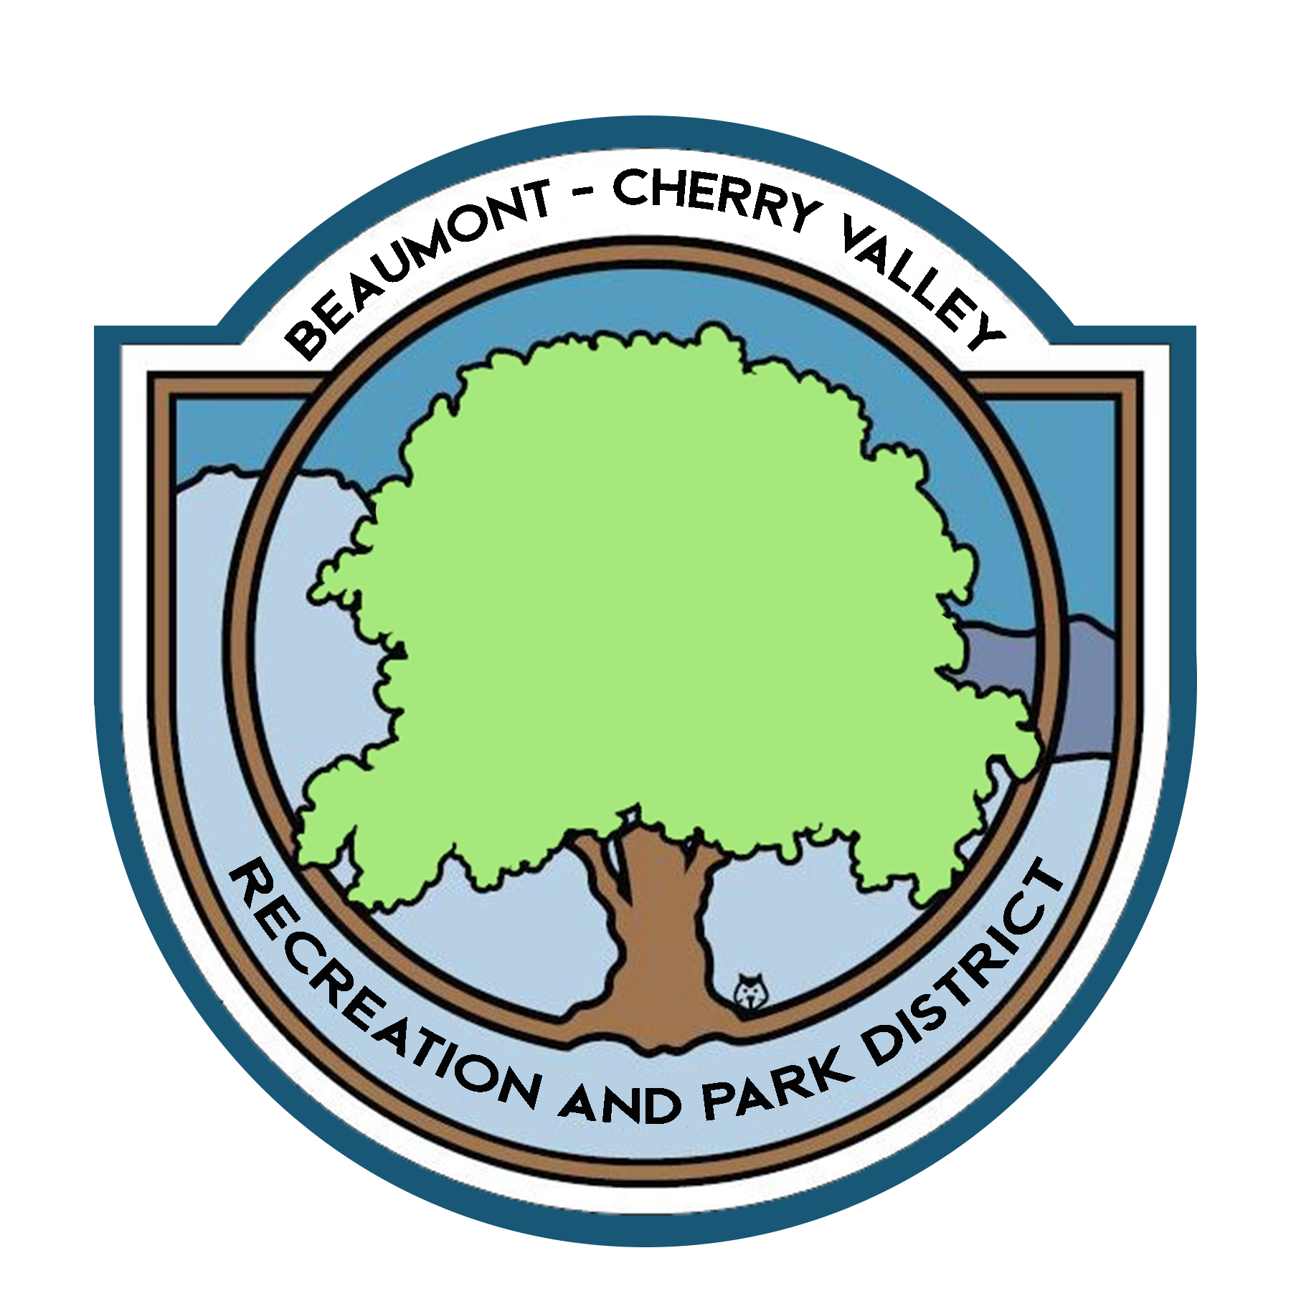

BEAUMONT CHERRY VALLEY RECREATION & PARK DISTRICT
FINANCE COMMITTEE MEETING
Monday, May 9th, 2022
390 W. Oak Valley Parkway Beaumont, CA 92223

MINUTES
www.bcvparks.com

REGULAR SESSION: Regular Session to Begin at 4:21pm

Roll Call:
Vice Chair/Secretary Diercks __X___ Treasurer Flores__X___ General Manager Burk _X_ Financial Services Technician/Office Manager Law __X___

Adjustments to Agenda: None

- PUBLIC COMMENT: None

- CONSENT CALENDAR:
- 2.1 Minutes of Monday, April 11th, 2022. Motion was made to approve minutes by Chris Diercks 2nd by John Flores.

- ACTION ITEMS
- 3.1 Financial Report April 2022. Motion was made to approve the finance package as submitted by Chris Diercks 2nd by John Flores.
Passed unopposed

- 3.2 Check Warrants April 2022. Motion was made to approve the check warrants by Chris Diercks 2nd by John Flores.
Passed unopposed

- 3.3 Riverside County Fund Request of $250,000.00 (Bills & Payroll) Motion was made to approve the request of $250,000.00 from the Riverside County Fund by Chris Diercks 2nd by John Flores.
Passed unopposed

- ADJORNMENT:
The meeting was adjourned by John Flores at 5:19pm

