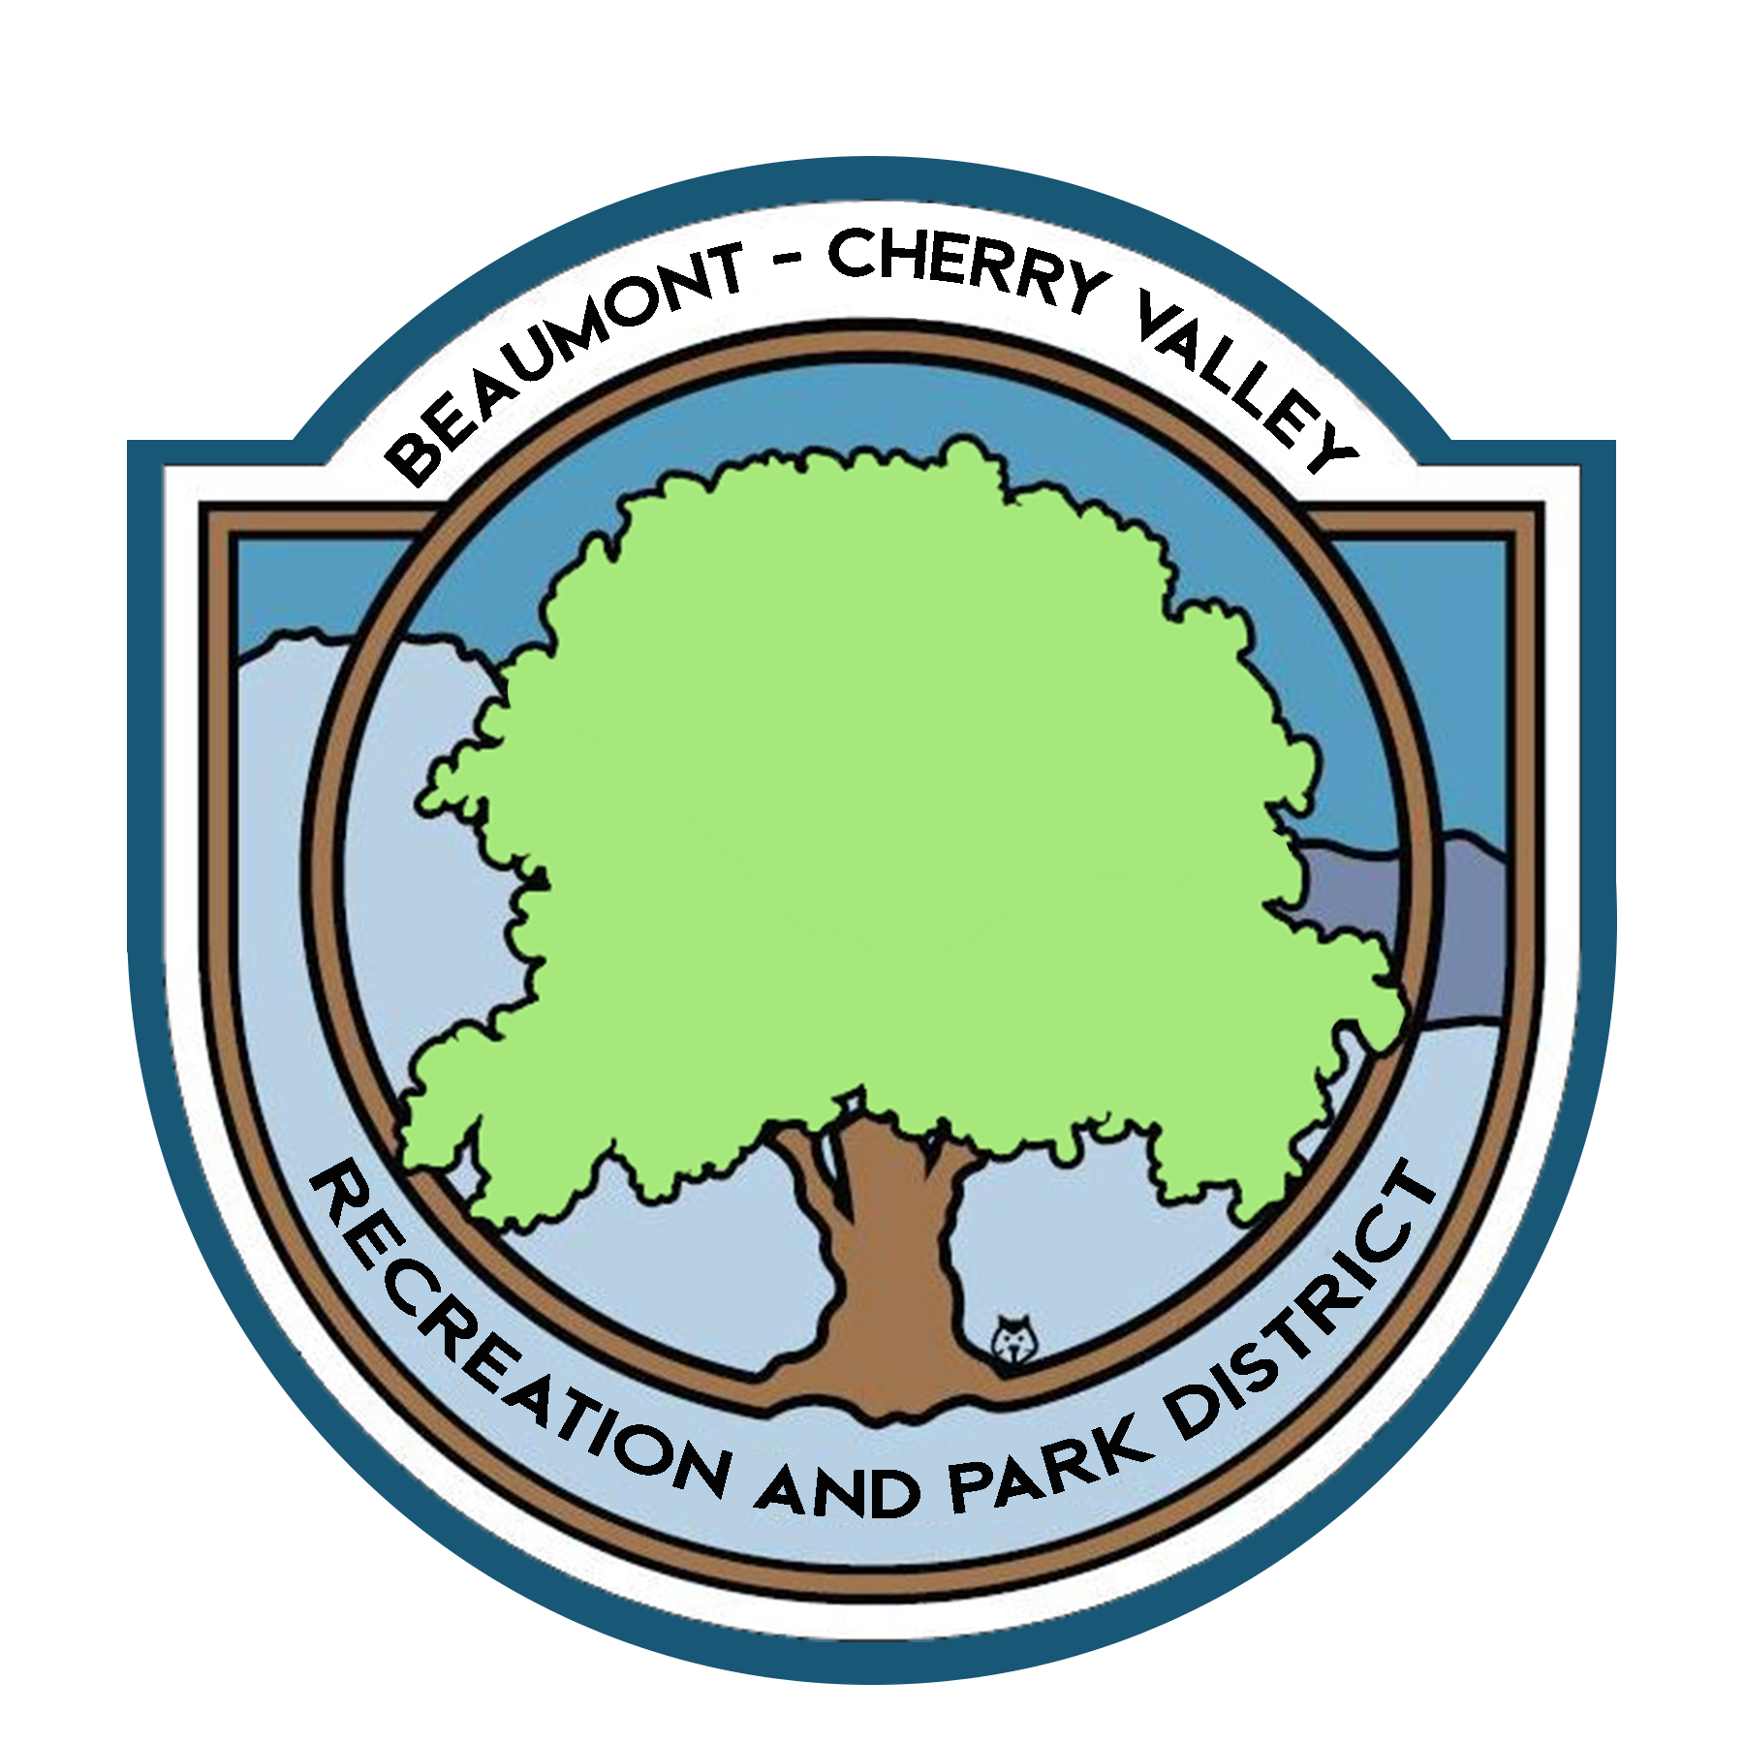

BEAUMONT CHERRY VALLEY RECREATION & PARK DISTRICT
FINANCE COMMITTEE MEETING
Monday, March 7th, 2022
390 W. Oak Valley Parkway Beaumont, CA 92223

MINUTES
www.bcvparks.com

REGULAR SESSION: Regular Session to Begin at 4:06pm

Roll Call:
Vice Chair/Secretary Diercks __X___ Treasurer Flores__X___ General Manager Burk _X_ Financial Services Technician/Office Manager Law __X___

Adjustments to Agenda: None

- PUBLIC COMMENT: None
- CONSENT CALENDAR:
- 2.1 Minutes of Thursday, February 3rd, 2022. Motion was made to approve minutes by Chris Diercks 2nd by John Flores.

- ACTION ITEMS
- 3.1 Financial Report February 2022. Motion was made to approve the finance package as submitted by Chris Diercks 2nd by John Flores.
Passed unopposed

- 3.2 Check Warrants February 2022. Motion was made to approve the check warrants by Chris Diercks 2nd by John Flores.
Passed unopposed

- 3.3 Riverside County Fund Request of $200,000.00 (Bills & Payroll) Motion was made to approve the request of $200,000.00 from the Riverside County Fund by Chris Diercks 2nd by John Flores.
Passed unopposed

- DISCUSSION:
  - 4.1 Profit & Loss Events, Profit and Loss of all current FY events was given and review by committee.
  - 4.2 UMPQUA Bank Rebate, Committee was notified the District received a rebate from UMPQUA in the amount of $211.52 for Purchases in 2021.
  - 4.3 County of Riverside UCF Funding, Duane let the committee know about the infrastructure funding award to the Foundation in the amount of $400,000.00. the Committee was accepting of the funding.
- ADJORNMENT:
The meeting was adjourned by John Flores at 5:02pm

